Cross NIHR ARC event (ARC East of England and ARC North West Coast)
Learning from COVID-19: NIHR ARC Research on visiting in care homes, 6th July 2021

Speaker Bio’s

CLARISSA GIEBEL
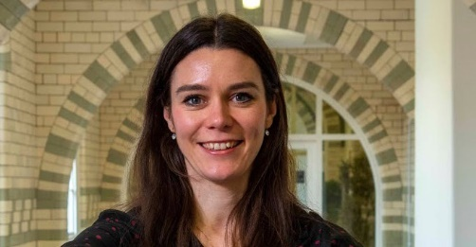
Dr Clarissa Giebel is a research fellow at the University of Liverpool and the NIHR ARC NWC, focusing on inequalities in ageing and dementia care. She is leading on a number of national and international projects with the Netherlands, Colombia, India, and Uganda, amongst others, and has led on COVID-19 research into the impact of the pandemic on dementia care in the community and in care homes.

KRYSTAL WARMOTH
Krystal Warmoth is a Research Fellow working within the NIHR Applied Research Collaboration (ARC) East of England at the University of Hertfordshire’s Centre for Research in Public Health and Community Care (CRIPACC). She is a social and health psychologist interested in how we can best support the health and well-being of older people with complex conditions. She currently is undertaking a THIS Institute fellowship which aims to co-produce a vision for primary care which enables consistent access to healthcare that reflects care home residents’ needs and priorities and how that can be achieved within current structures and resources and leads the STOPPING project which aims to inform the development of a deprescribing (the reducing or stopping of medicines) approach for older people in care homes and funded by NIHR RfPB.

CLAIRE SURR
Claire Surr is Professor of Dementia Studies and Director of the Centre for Dementia Research at Leeds Beckett University.
Claire has worked in dementia care and services research for over 20 years. Her particular interests lie in developing and evaluating interventions to support the delivery of person-centred care for people with dementia in settings such as care homes and hospitals. She is also recognised internationally for her expertise on the effective approaches to educate and train staff working in health and social care about dementia.

JOSIE DIXON
Josie Dixon is based at the Care Policy and Evaluation Centre (CPEC) at the London School of Economics and Political Science. Her research focuses on ageing and care, particularly end-of-life care, dementia care, and social care for older people. She currently leads research on the NIHR-funded project, Visit-id, a study of care home visiting during the Covid-19 pandemic, and the Alzheimer’s Society-funded project, PrepareD, a study on preparing for future care in dementia. She is also a co-applicant on a range of projects including DETERMIND, an ESRC/ NIHR-funded study examining inequalities in dementia care. Josie is primarily a qualitative specialist but able to work across a range of methods. In previous roles, Josie has directed government and other nationally commissioned research and worked with local leaders to improve strategic planning and service provision (through consultancy, research, value for money assessment, and inspection).

