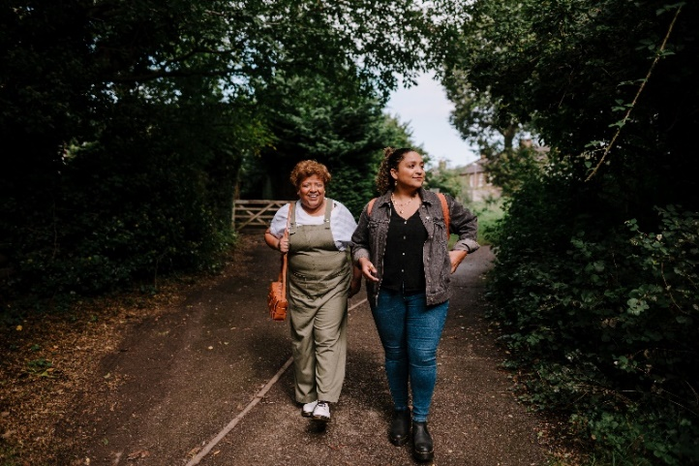
Walking Interviews
(also known as “Going Along Interviews”,
“Walking Alongside”)

How are Walking Interviews Organised? You might ask one question at the beginning to get people going (not really an interview). It feels like something you are doing together, the ‘interviewer’ felt like a supportive, facilitative person., rather than steering the person through an interview guide, let the person talk about the things they want to. Might be useful to think of doing walking interviews in a group way, rather than individual (as people may have anxiety or lack confidence). Good approach for constructing knowledge jointly. Relationship between knowledge gatherer and knowledge giver, much more of a co-productive activity. Still feasible if people have mobility restrictions, for example, if wheelchair users, by tailoring the ‘walk’ to accommodate their impairment and support needs.
What modifications could ensure the method was inclusive? People suggested other ways of enabling people to talk when they are doing something they enjoy (playing with lego, car journey) and avoiding direct eye contact. Can be used for meetings as well.
Why it might be a useful method to try | Challenges to be mindful of
No awkward silences – there can be silences (not awkward) | Weather conditions, windy, rain, cold
Participant has control, as they decide where to walk | Not everyone can walk or walk a significant distance
No direct eye contact (“holding the gaze” in conventual interviews, subordination). People are free to move around, look around, talk or not talk. Shared interaction. | People may have anxiety or lack of confidence to do a one-to-one walking interview.
Can be really useful for those people who are not often involved in research or more anxious about research | Weather or group walks might make audio recording difficult
Good for neurodiverse ways of thinking | How to analyse from one question?
Good to hear from people when they are doing something they enjoy
Alongside rather than face to face, less confrontation and build a relationship. Less intimidating.
On the move, changing landscape to respond to
Might be good for younger people
Access advice, visual - move around a building, signage, the minutia, whole journey, natural prompts to conversation, physically demonstrating access barriers.
Eye contact can be quite tiring for autistic people.
Walking alongside people (walking the dog, walking to the shops), especially when it is cold. Sparks observations.

Advantages:
- People can be more natural, comfortable, more pauses to think.
- People can point out things that have meaning to them
Examples:
- Video made with care leavers, they then took control of the ‘data’ and decided what to use for their story.
- Joining an on-going walking group (women on probation), to build up trust before more ‘usual interviews’, i.e. building up relationships first.

Introduced by Peter Beresford

