Palliative Care – Amanda Farwell, 28th October 2025
PhD: Working in partnership with heart failure patients and carers to improve end of life conversations and palliative care provision with clinicians | ARC East of England

There is limited literature around end-of-life preferences and palliative care especially from heart failure patients despite these conversations needing to happen. Amanda’s presentation discussed how to include potentially frail participants in research and involve their lived experience. Amanda was a nurse for 30 years with 13 years of that spent as a heart failure nurse. While she was used to having conversations with patients and their caregivers planning their end-of-life care, not all her colleagues had the same approach, with many feeling uncomfortable.
There are preconceived ideas about palliative care with many people assuming a patient is actively dying, is poorly, lying in bed, or taking their last breaths. The World Health Organisation (2020), defines palliative care as “an approach that improves the quality of life of patients (adults and children) and their families who are facing problems associated with life-threatening illness. It prevents and relieves suffering through the early identification, correct assessment and treatment of pain and other problems, whether physical, psychosocial or spiritual.” https://www.who.int/news-room/fact-sheets/detail/palliative-care. Therefore, someone receiving palliative care should not be assumed to be actively dying.
Much of the literature alludes to patients being too frail to partake in research or it being unethical to involve them. Amanda asked the Community of Practice audience to vote on which groups they would feel least comfortable recruiting (see Slido below). Amanda explained that potentially any of the groups listed could have heart failure, a terminal condition which patients can die from.

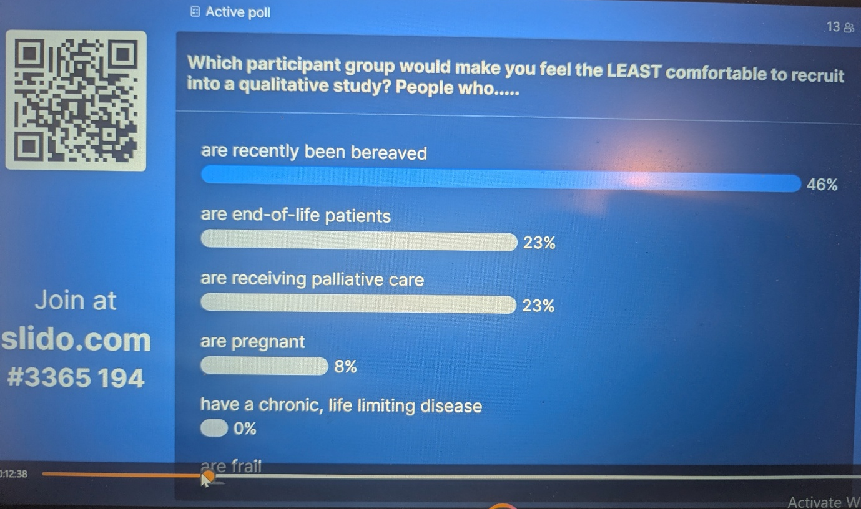
A reluctance to recruit end of life patients.
With heart failure the trajectory of the disease (unlike cancer which progressively gets worse), can have episodes of feeling better and then a deterioration in symptoms. This makes it difficult to judge when conversations should happen. Amanda explored with the audience reasons for the reluctance to recruit end of life patients into research.

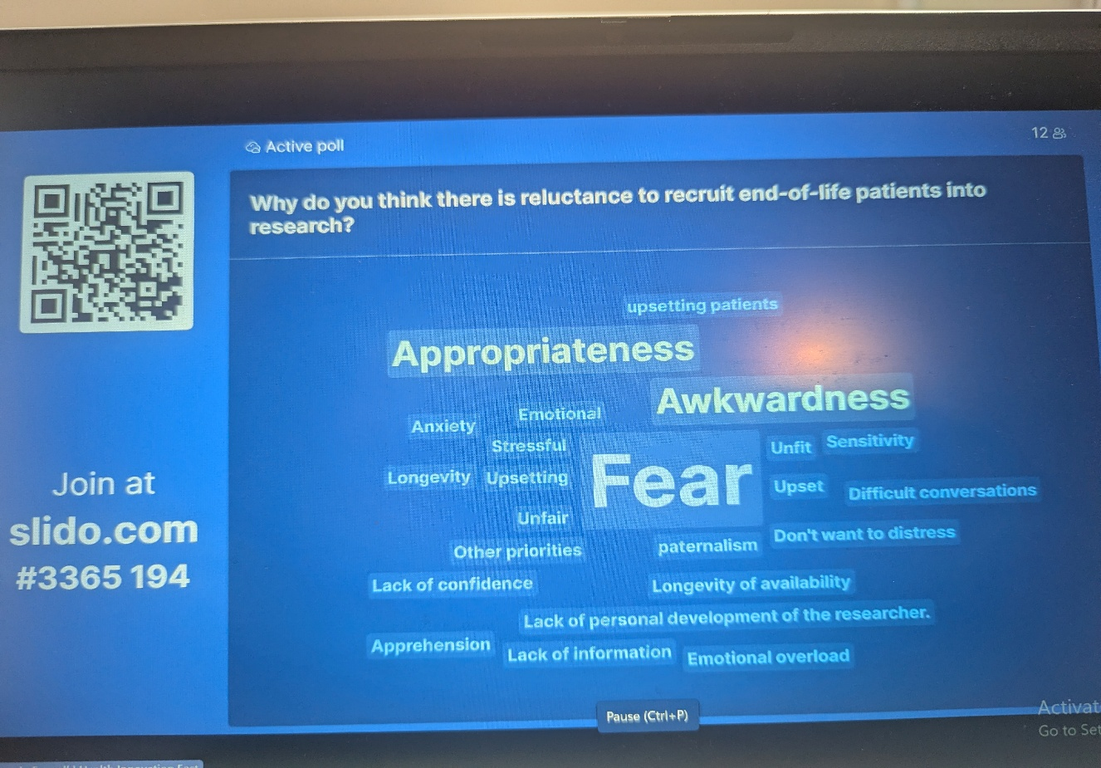

Amanda spoke of apprehension, awkwardness and the fear end-of-life conversations can create. In the literature healthcare professionals are identified as not wanting to cause distress to their patients, but patients often want to talk about their experiences and give back to improve services and experiences for other patients. Issues of paternalism can also exist with healthcare professionals wanting to protect their patients. In Amanda’s research there were emotions during the interviews, but patients found it beneficial and wanted to share their experiences.

Different backgrounds and minority groups.
Thought was given to those who might experience difficulties in accessing end of life services; for example, those in same sex relationships, minority ethnic communities who speak different languages and have different cultural beliefs, and those with learning disabilities and autism. A limitation of this research was the lack of diversity of participants – they were mainly white and British.

Steps to involve end-of-life participants in research
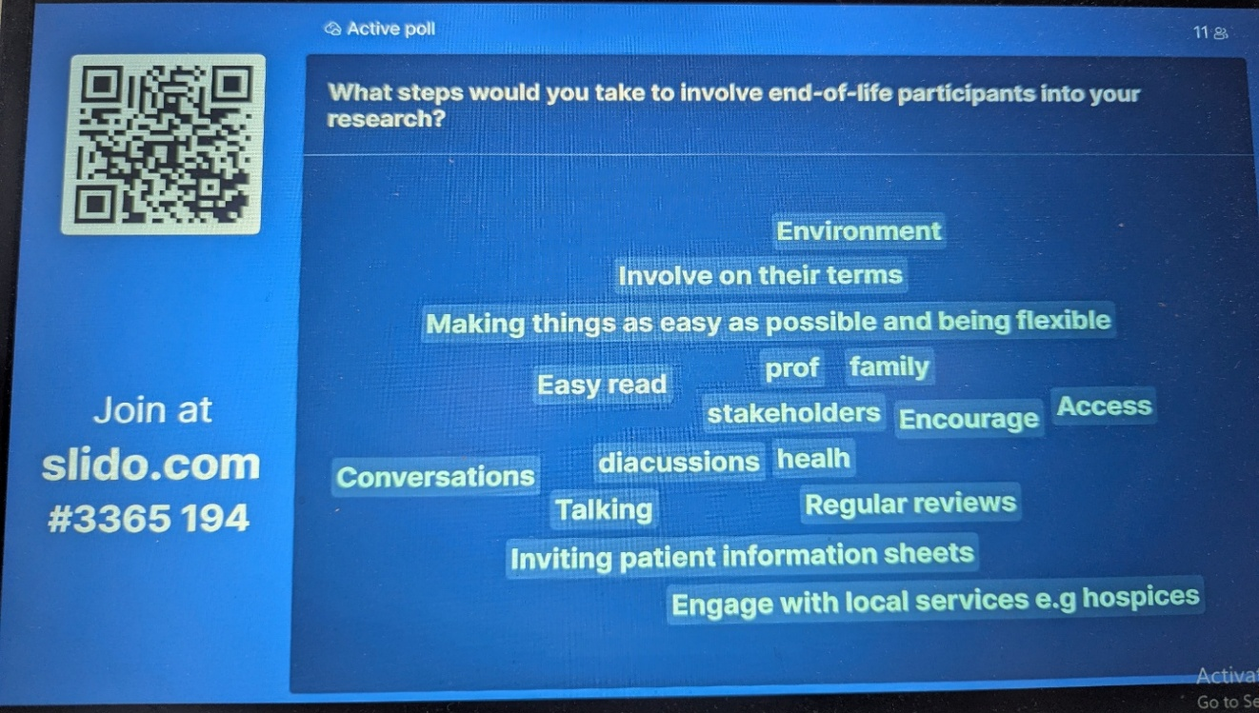

Access was considered and the role of healthcare professionals who may feel uncomfortable and reluctant to act as a gatekeepers for research if patients are vulnerable, frail, end of life or requiring palliative care. Another example was given of care home research, and residents being directed to the researcher who may be put in a difficult position of being unsure if residents are truly willing to participate or if they feel an obligation to. Amanda spoke about her experience of using an online platform to recruit patients. Participants could put themselves forward, and this was an active choice on their part as they had already read information about the study and were happy to be involved instead of just being referred to her. Amanda had been fortunate to link up with a National Heart Failure charity called pumping marvellous who supported her throughout the research process.

Ethics and issues of consent were important (and considering the effects or consequences of the research). A lot of time could be spent considering distress protocols and ethics panels may still have reservations due to the sensitiveness of the research. Consent should be an ongoing process, and in this research on the morning/afternoon of a patient interview, Amanda would check in to ensure there were no issues and that they were feeling ok symptomatically and stable. She was able to use her clinical skills but suggested it might be more difficult for those without clinical training, but a simple thing would be to ask participants. After the interview (the following day or a week later) she would also check in with patients again and the timing of this was based upon how the interview had gone.

Stress, anxiety from relatives, or a fear of upsetting patients, was also discussed. Amanda spoke of the importance of knowing how you would deal with any distress or upset and stating this within the ethics application. In this research participants could be given the option of postponing an interview.

The importance of looking after yourself as a researcher and ensuring you had your support network such as supervisors, or colleagues was explored. The audience discussed the role of boundaries, especially when a clinician is doing research. Audience members reflected on how it could be difficult not to intervene in a dual role as a researcher and clinician. It was noted that Amanda’s credibility as a clinician may have made it easier for participants to talk to her about their experiences.

Amanda felt that working alongside the heart failure charity and following their guidance gave her research further robustness and credibility as their guidance and expertise informed the research. The analysis was shared with the charity to ensure the data resonated with patient voices. One of the main findings was how there is no standardised approach to support end-of-life patients with heart failure. Furthermore, community heart failure nurses are not available everywhere, although they are ideally placed to provide support and general palliative care which is not restricted by clinic appointment schedules. The discussion ended with exploring how confident people would now be to recruit end of life participants.

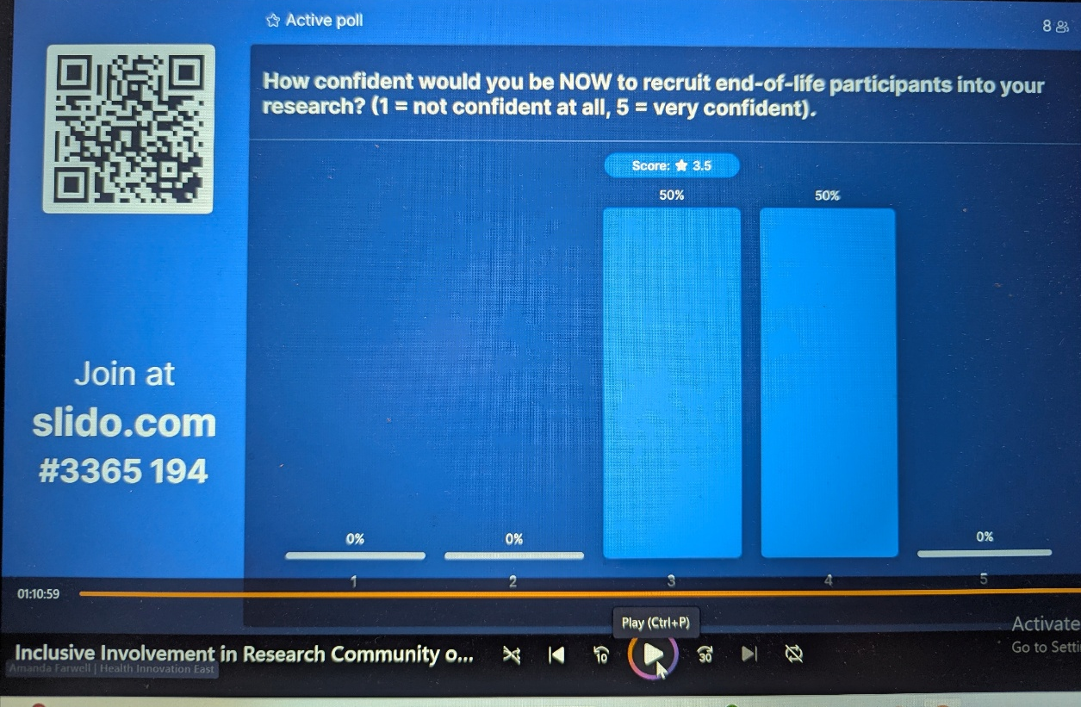
Links and Resources
Beresford, P. Adshead, L. and Croft, S. (2007), Palliative Care, Social Work And Service Users: Making life possible, London, Jessica Kingsley.

Caroline Barry has done some work which may be interest: Palliative Care - Capacity consent research

The Daple Project - a 3-year research study (2024-2027) to find the best ways to make sure that people with a learning disability get the right care and support at the end of their lives https://www.dappleproject.com/

ARC East of England theme on Palliative and end of life care

