**The DiTSoW Research Advisory Group Shaping the Future of Digital Inclusion. Introducing ‘Wired and Wise:** **What is important to older people when considering technology use and development?’**

**(Authors: Leisha O’Brien, Alison Tingle, Raj Mehta, Anne Pridmore and Kathryn Almack)**

Research is about real people, real experiences, and real impact. The most valuable research happens when people with lived experience are involved in every step of the process.

The DiTSoW (Digital Technologies to support Social Wellbeing of older adults) Research Advisory Group (RAG) are a group of eight older people who bring both a wealth of lived experience and professional skills. They influence the DiTSoW study, from shaping the research design to ensure that findings reflect the realities of older people and are useful to decision makers in social care.

To amplify their work, we’ve launched a special one-off podcast - a space where the voices, insights, and discussions of the RAG come to life. This podcast gives a behind-the-scenes look at the rich mixture of perspectives and discussions that happen regularly during the RAG meetings, led by the University of Hertfordshire’s research team.

**Podcast: Wired and Wise:** **What is important to older people when considering technology use and development?** <https://open.spotify.com/show/5hxzUFjgrlHBcpqZgUY2Ez?si=jjbuC44BRuqiHQPh2Ew3BQ>

The topics covered in the podcast are close to the hearts of the RAG members, exploring important issues around digital technologies, such as:

* concerns about technology and staying safe online
* the challenges of setting up devices
* pros and cons of accessibility settings and artificial intelligence
* the impact of sensory and cognitive impairments
* where older people can get help from to use technology

Key takeaways for creating a podcast trying something new without a podcasting expert can be exciting and nerve-wracking but it’s possible to do without professional help.

* most people aren’t fond of the sound of their own voice, which can cause some self-consciousness while recording.
* Remember, everything can be edited! Don’t worry if you make a mistake – just record it again
* you don’t need to have your camera on if it adds to your self-consciousness

**RAG’s advice and reflections**

* Stay flexible and adapt to how people prefer to work. In our podcast, we mix recordings from online discussions, one-to-one chats, and individuals recording from their homes.

Throughout the DiTSoW journey, the RAG team has worked together to make research more inclusive. The group’s collaborative and equitable approach has given them hands-on involvement in the research process

In 2023, the RAG members played a pivotal role in organising and leading two World Café-style events, which brought together older people, tech developers, charities, and local authorities to discuss how digital technology can improve social wellbeing and develop some recommendations for policy and practice. These events were designed to be accessible and welcoming to older people and people with disabilities.

One event was in-person, the other was online. In both, RAG members took on active roles such as facilitators, timekeepers, and group discussion participants. Their goal was to encourage older adults and people with disabilities to engage in the events and share their opinions.

To prepare for these roles, the researchers provided specialist training through the NIHR network, created user-friendly facilitator guides, and gave advance lists of attendees to ensure everything went smoothly.

“*For me it all comes back to collaborative working. We spent lots of time upfront, including training and that really made this work stand out.*” RAG member, Raj.

The events were captured by an artist who recorded the discussions in real time. This helped people see their ideas coming to life, energising the room.

*‘The board they were using was, I don't know, 8ft by 5ft, something like that. It was huge. The artists weren't actually taking part in the discussions they were taking the feedback, going to all the scribble boards that were dotted around where people are putting on thoughts. So, they were able to get onto one document, probably more ideas than we were actually aware of during the discussion.  I think it condenses many, many pages of information to a single page.  I think, is a really good tool.’* RAG member

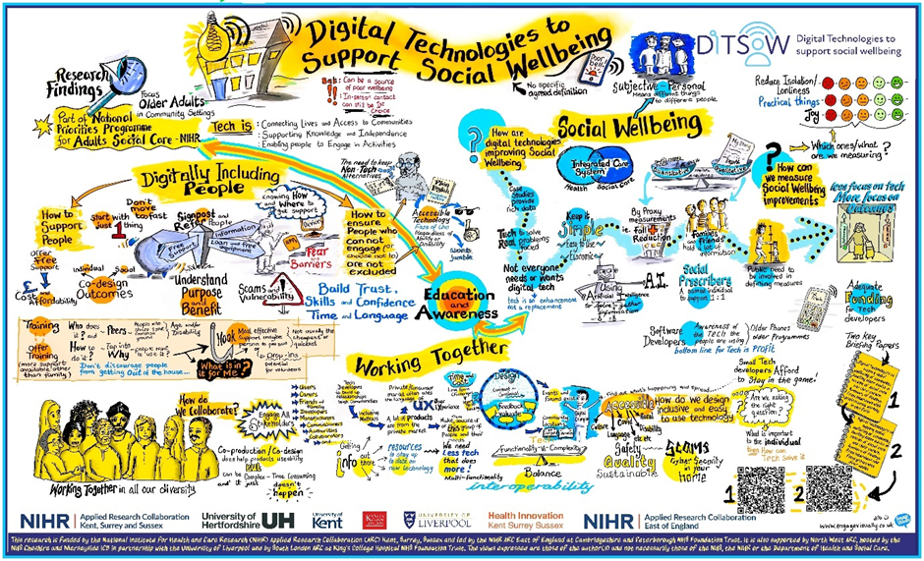

To ensure accessibility, the RAG suggested creating an audio description of the graphic for people with visual impairment. The description provided a spoken overview of the image, explaining the colours, shapes, people, and details so that those with sight loss could form a mental picture.

Here is a link to the audio description: [Audio Description](C:\\Users\\at21acd\\OneDrive - University of Hertfordshire\\IPASC - ARC Folder\\Digital tech\\OUTPUTS\\audio description\\riverside_ditsow_graphic record audio description_leisha_o'brien's st.mp3)

Rather than hiring a professional, the RAG encouraged a researcher to try audio describing themselves, to better understand the experience of sight loss.

**What did the researcher learn?** Click here to learn more about audio description <insert hyperlink to pop out with the detail below about audio description so that it doesn’t detract from the article being about the RAG?>

**The impact of collaboration and co-production**

The collaboration between the RAG and researchers how powerful equity and shared knowledge can be. It has not only improved the research but also made the events and outcomes more engaging, inclusive, and meaningful for everyone.

‘*Working in a co-production together is always the right way to work.  Whilst we all have individual ideas any research that involves people with lived experience is going to be a positive approach and have a more meaningful end result. The RAG group worked well because I had confidence that my views would be valued.*’ RAG member, Anne.

**Audio description pop out box**

**Audio description: the value for researchers**

When you try audio description yourself, you quickly realise how much detail sighted people take for granted. You begin to understand how much is left out for people with sight loss – whether in research outputs, study materials, or public engagement activities

This experience deepens your understanding of inclusion. It helps you think beyond basic accessibility and focus on making research experiences meaningful for everyone.

You also realise that some people had never had sight, while others have lost it - and these two experiences require different approaches to description.

It’s valuable to get expert advice before trying audio description. Our researcher worked with Warren Wilson, Community Connector at RNIB, and there are also training opportunities from organisations like [VocalEyes](https://vocaleyes.co.uk/).

**Here are some tips to start:**

* Begin with a general statement about the image to give the listener an overall sense e.g. “This picture is very busy, with most of the paper covered in illustrations but there is a lot of empty white space”
* Break down complex images into sections.
* Think about the key element of the image and describe them clearly but without overwhelming the listener.

**What to describe**

* Colour: go beyond just naming the colour - describe it’s feeling. For example, “warm yellow”, or “cool blue”
* Size: don’t just give exact measurements – bring it to life. For example, “colossal” or “tiny”
* Scale: compare sizes to everyday objects, for example “smaller than a coin”
* Shape: relate shapes to familiar objects, for example “pointed, like a pencil”
* Feel: if relevant, describe the texture, for example “smooth” or “bumpy”
* Perspective: describe the relationship between objects, for example “the tree is far in the background”
* Medium: mention what materials are used, for example “watercolours” or “felt tips”