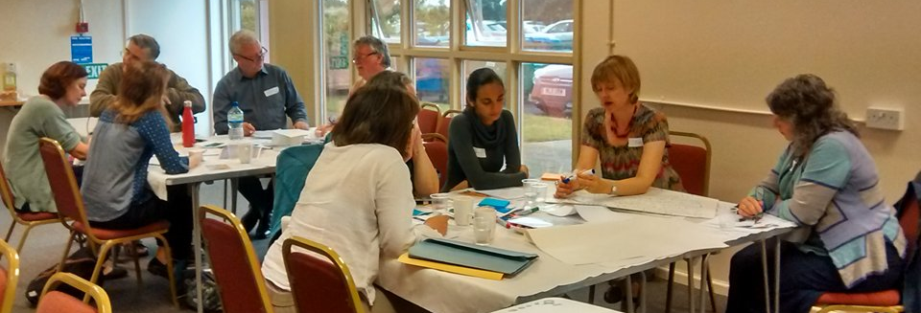
World Café
7 Design Principles
1) Clarify Context
2) Create hospitable space
3) Explore questions that matter
4) Encourage everyone's contribution
5) Connect Diverse perspectives
6) Listen together for patterns and insights
7) Share collective discoveries

What is World Café? To encourage the inclusion of different voices. Not everyone wants to raise their hand in a meeting, or speak in front of lots of people, so having small group discussions can be helpful. Each table has a mixture of people (e.g. public members, researchers).
How is the World Café Organised? In a community building, accessible (disabled parking, reimburse taxi fares), sufficient free parking, tables set out in a café style, snacks and drinks on each table, ‘write on’ tables cloths, post-it notes (for those who didn’t want to verbalise ideas) and an appointed facilitator on each table. Each table had a topic, and at the end of each discussion period everyone moves around. The facilitator at each table summs up the previous discussion and the new group then have the chance to agree or disagree and add their views about that table’s topic. Once everyone has had a chance to contribute to every table (and therefore to every topic), come back to summarise. Afterwards, all written material is written up and circulated to those attending (offering the opportunity for additions or clarity).
What modifications could ensure the methods was inclusive? After the first discussion, when the facilitator asked people to move to the next table, a couple of public contributors said they did not want to move. They had settled at the table, with coats and belongings and preferred to stay put. One public contributor who used a mobility frame, said he preferred to stay where he was. We adapted the method by asking the facilitator to change tables rather than the participants. If only a few people turn up, the method will have to be adapted to fewer tables.
People Moving Around the Tables | People Staying on the Same Table
Hear a wide range of views | Easier access in terms of movement (Wheelchair access)  Some parts of the room are easier to be in than other parts
Mix up the people in your discussion group | Stay with same group of people (build relationships)
People have more control over where and who they sit with | People do not have to meet lots of new people (could become overwhelming)
Advantage for facilitator, as does not have to move (and notes etc). | Avoiding too much movement and meeting too many new people can be helpful for people with autism
 | Helpful for those who need to lip read (stay with same people)
 | People who have supporters/personal assistants can sit together
 | Helpful for those who need to access hearing loop
Advantages
- Informal way of discussing a number of topics with different people.
- By discussing each topic, people get an opportunity to input to the ‘whole’.
- People hear different viewpoints
- The experience can be stimulating, enjoyment is part of researching
Recommendations:
- Encourage people to add further comments after the World Café - people do not always think ‘on the spot’. This could be written or verbal (using a digital recorder or phone call).
- Encourage people to draw their ‘ideas’, does not have to be written. Illiterate
- Lastly, shared decision making – importance of being transparent, communication after the event.
An example of using this method: Developing the Patient and Public Involvement Feedback Guidance.
World Café Website: http://www.theworldcafe.com/key-concepts-resources/world-cafe-method/
Introduced by Elspeth Mathie, Graham Rhodes and Amander Wellings. (e.j.Mathie@herts.ac.uk)

