Universal Design in Research: Can Disabled People Access Your Research?
Introduced by Katherine Deane (K.Deane@uea.ac.uk)
“Ableism” is one of the most common biases that is socially acceptable.
- Disability is very diverse (mobility, vision, hearing, energy, cognition, mental wellbeing) and includes pain, fatigue and brain fog. All affect ability to take part in research.
- Just World Theory: “if I am disabled, I did something wrong”.
- Disability is often seen as negative - ‘broken, charity case, inspirational or fraud’.
- The social model of disability, “what am I doing that is disabling my potential participants”. How do people with a disability know they could take part and have their needs accommodated?
- As a researcher you have a responsibility to undertake the ‘accommodations’ for your participants.
- Disability is all-inclusive – anyone can be disabled. Taking an intersectional viewpoint, people can be many things (wheelchair users, woman and mother) and also recognising positions of privilege.
- Access to healthcare is a right, therefore, access to research is a right.
- Currently living in a hostile environment, COVID and Cost of Living, access to benefits cut. Research can be seen as an additional burden.
- Importance of social niceties, tea and biscuits, travel costs, time for social time.

Our discussion;
- As well as asking “What can I do for you to join? (where the onus is on the person)” - try and do what you can to start with, this will build trust. No such thing as having ‘too accessible’ information.
- Think of sending photos of venues, pre-meetings, have a quiet room available. Map of walk from bus stop to venue. Weblink to venue. We can provide BSL, step free room. We have thought about you, would you like to come? Dimension of toilet space – makes invite more real (we do mean ‘you’ are invited).
- Patient Information sheets: EasyRead – easier for everyone. How many people give true ‘informed consent’ in reality, do people read all the small print? We discussed ethics and making processes more accessible.
- Inclusion is often under resourced and underfunded.
- Service users should be involved in making videos and Guidance on inclusion.
- Be willing to make mistakes, researchers should try, there is no such thing as perfect. Admitting failure and reflect on how to do things better next time.
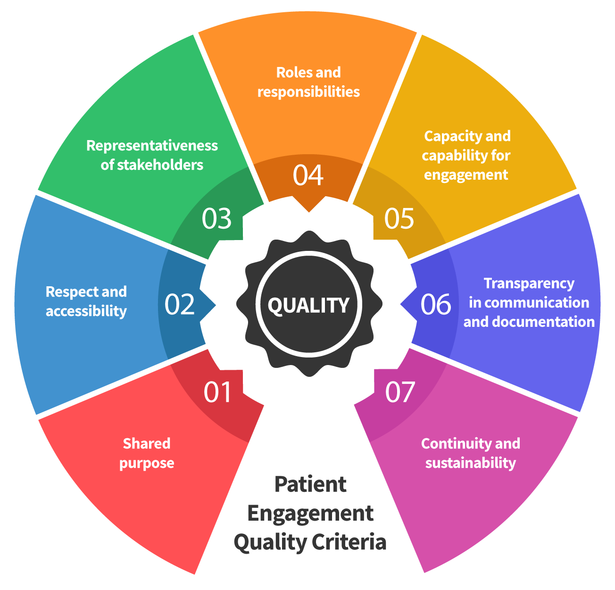
Links and Resources
Have I thought about all these areas to do Patient Engagement or involve people in your research?
- Shared Purpose
- Respect and accessibility
- Representativeness of stakeholders
- Roles and responsibilities
- Capacity and capability for engagement
- Transparency in communication and documentation
- Continuity and sustainability
Do not reproduce without acknowledgment:
Deane, K. et al, (2019) Co-creation of patient engagement quality guidance for medicines development: an international multistakeholder initiative, BMJ Innovations, 13. https://innovations.bmj.com/content/5/1/43
Other links:
https://butyoudontlooksick.com/articles/written-by-christine/the-spoon-theory/
https://patientfocusedmedicine.org/ has a lot of resources on how to do good PPI – aimed at the pharmaceutical world but the principles are sound.
https://www.nihr.ac.uk/documents/improving-inclusion-of-under-served-groups-in-clinical-research-guidance-from-include-project/25435 is NIHR’s guidance on improving access of under served groups to research – including the disabled community
Panel Member “What changes are already making a difference in research culture?” https://wellcome.org/news/which-changes-are-already-making-difference-research-culture

Podcast where I discuss failure and how important it is for research. Values, disability, saying no, and how fabulous it is to fail during the research process. Oct 2021 https://emmaelvidge.wordpress.com/2021/10/26/episode_2_katherine_deane/

Talk where I discuss the value of having disabled scientists – particularly in the context of inspiring and encouraging the next generation of scientists by visits to science and discovery centres and ensuring they are really accessible. Deane K. Benefits of being a Disabled Scientist. UK Association for Science and Discovery Centres. 01 Jun 2020 https://www.youtube.com/watch?v=vjMHySCxY2k&feature=youtu.be
Talk about some of the more toxic attitudes around disability – and the impact this has on the design of science and discovery centres. Deane K. Your Attitude Sucks! UK Association for Science and Discovery Centres. 01 Jun 2020 https://www.youtube.com/watch?v=pUn5RVW9JlA&t=130s

Talk about how to engage and consult well with disabled communities – particularly in the context of the design of the infrastructure and displays at science and discovery centres. Deane K. How to Screw Up, and how not to! UK Association for Science and Discovery Centres. 01 Jun 2020 https://www.youtube.com/watch?v=THkZIOmvQxg&t=32s

